Heat Transfer Analysis of Engine Cylinder Fins by Varying Materials

Vishwjeet Singh1*, Shiv Darshan1

*1Department of Mechanical Engineering*

*Bansal Institute of Engineering & Technology, Lucknow (U.P) – 226201*

***Abstract:*** *This paper aims to carry out a heat transfer analysis of IC (Internal combustion) engine Fins for different fin materials. For this purpose, the Hero Super Splendor motorcycle has been taken into consideration. A parametric model of a Rectangular Engine Fin has been created to study the heat transfer and temperature distribution of the Engine fins. The steady-state thermal behavior of the engine fin is studied in this paper. The 3D model is created with the software of the Solid work. Steady-state thermal analysis is done using Ansys software. The currently used material for the fin is Al204 and the materials used for comparison are Al6061 and Al6063. The result is compared to find the best material which gives a better heat transfer rate and has good strength and should be light in weight.*

***Keywords:* Heat Transfer, Internal Combustion Engine, Fins Material, Ansys software, Hero Super Splendor motorcycle**

# INTRODUCTION

IC (Internal Combustion) engine is a kind of Heat Engine. This contains a combustion chamber in which the combustion takes place with the help of an oxidizer (generally air). In IC Engine expansion of gases occurs at high pressure and high temperature due to combustion, and a force is exerted on the components of the engine. This force is exerted on the turbine blade, rotor, nozzle, or pistons. Due to this force component moves to a distance and consequently transforms the chemical energy into work. In 1860 Etienne Lenoir created the first commercial IC Engine but the first modern IC Engine was created by Nicolas Otto in 1876. In IC Engines combustion is generally intermittent such as 2-stroke and 4-stroke engines which are more familiar. Also, there exists a 6-stroke piston engine and the Wankel rotary engine. A second type of IC Engine also exists in which the combustion is continuous. e.g.- Jet Engines, Rocket Engines, and Gas Turbines [1-3]. In the External combustion Engines, in contrast, working fluid (liquid or gas or both) is heated by fuel burnt outside the engine. IC Engine is most famous in 4-stroke and 2-stroke type of engine. In this, the fuel used is primarily gasoline & Diesel. Examples of the 4-stroke engine are Car, Truck, Motorbikes, etc. Examples of 2-stroke Engines are mopeds, Scooters, Karts, Ships, etc. As the main propulsion Engine in the ship, the 2-stroke engine is used primarily due to the burning capacity of low-grade fuel which eventually results in low running cost. The thermal and Engine efficiency of a 2-stroke engine is much better as compared to a 4-stroke engine. Due to the High torque to weight ratio of 2-stroke engines 2-stroke engines require less maintenance. [4,5]

# METHODOLOGY

**2.1 PROPOSED METHODOLOGY**

In automobile engines, various components are subjected to a chance of wear and tear during the process of combustion. This happens due to the excessive amount of heat developed during the combustion of fuel. As in lighter engines, air cooling is preferred over liquid cooling due to various reasons, it becomes necessary to keep an eye on heat transfer of the air-cooling phenomenon. In air-cooled engines, heat transfer is relatively less as compared to liquid-cooled engines, which comes out to be a major problem using these engines. To overcome this problem the concept of the extended surface phenomenon came into the picture and these extended surfaces are named fins. Still, there are some cases in which more heat transfer rate is required. For this purpose, one has to move forward towards the design of fins. Fin design is mainly dependent on two factors [6-8]

* The geometry of fins.
* The material of fins.

In this research, materials of fins have been taken into consideration. There has been performed an analysis of Super Splendor bike fin in a steady-state manner varying different materials. A Rectangular fin is modeled with the help of fin data collected for the Super Splendor bike. Thereafter Finite element analysis is performed for various materials. In the end, the result of the analysis is compared mutually and suitable material is discussed [9].

**2.2 FIN PROFILE**

A rectangular fin of L as length and 2δ as thickness and W width of fin is shown below. Assuming the heat flow unidirectional and along the length.



**Figure 1: Rectangular fin profile [16]**



**Figure 2: Rectangular Fin**

**Table 1: DESIGN FOR THE SPECIFICATION [38]**

|  |  |
| --- | --- |
| Bore | 52.4 mm |
| Stroke | 57.8 mm |
| Thickness of fins | 2 mm |
| Pitch | 9 mm |
| Cylinder Wall thickness | 3 mm |
| Length of fin | 68.4 mm |

**2.3 BOUNDARY CONDITIONS**

The boundary condition for steady-state thermal analysis is taken as follows-

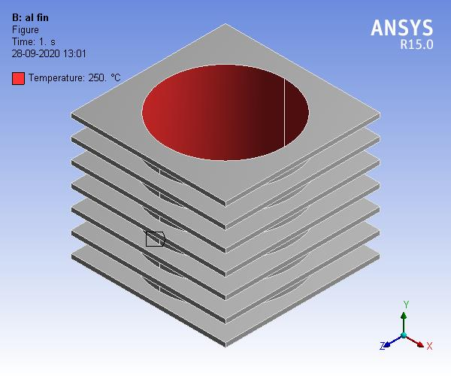

**Figure 3:** **Temperature Input for analysis**

**2.4 INPUT TEMPERATURE**

The analysis is carried out in steady-state conditions the input temperature at which the engine is in running condition is taken as 250 0C (ramped) [10]

**2.5 INITIAL PARAMETER FOR CONVECTION**

Initial parameters for convection like atmospheric temperature and heat transfer coefficients are as taken below.

Atmospheric temperature- 24 0C

Heat transfer coefficient -25W/m2K

# RESULTS AND DISCUSSION

A rectangular fin of the given specification is modeled by using Solid works software. The specification has been taken of the motorcycle Hero Super Splendor and analyzed the temperature distribution and heat flux of the same for different materials with the help of Ansys software. The analysis and the results obtained are shown for the materials Al 204 alloy, Al6061 alloy, and Mg alloy.

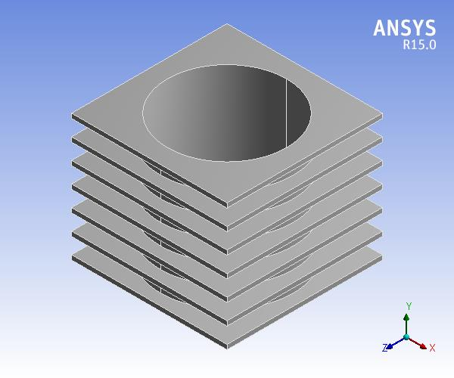

**Figure 4: Geometry of modeled rectangular fin**

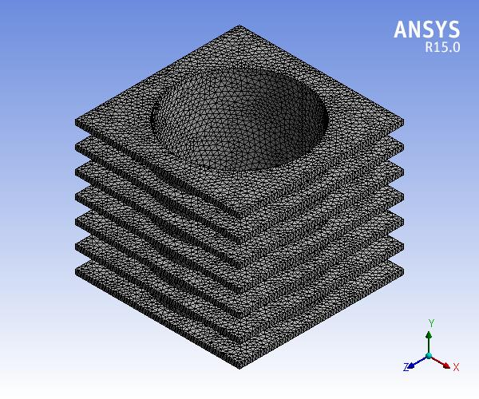Figure **5: Mesh in Rectangular fin**

**Table 2: Nodes and elements**

|  |  |
| --- | --- |
| **Rectangular Fin** |  |
| Nodes | Elements |
| 178913 | 101744 |

## 

## 3.1 AL204 ALLOY

**Table 3****: Material Properties: [11]**

|  |  |
| --- | --- |
| **Property** | **Value** |
| Density(Kg/m3) | 2800 |
| Specific heat (J/Kg/0c) | 960 |
| Thermal Conductivity (Watt/m/0c) | 120 |

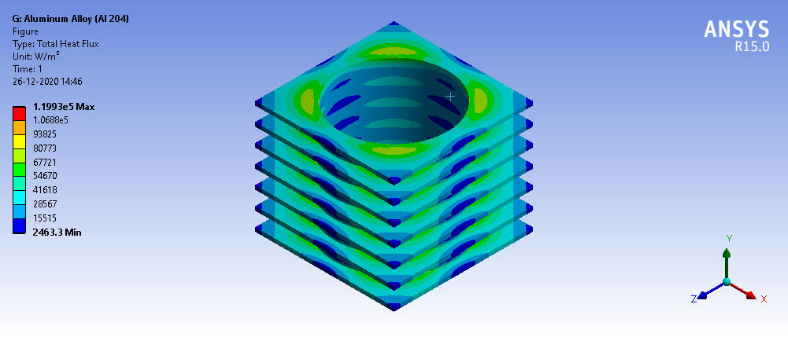

**Figure 6: Total heat flux in Al204 alloy**

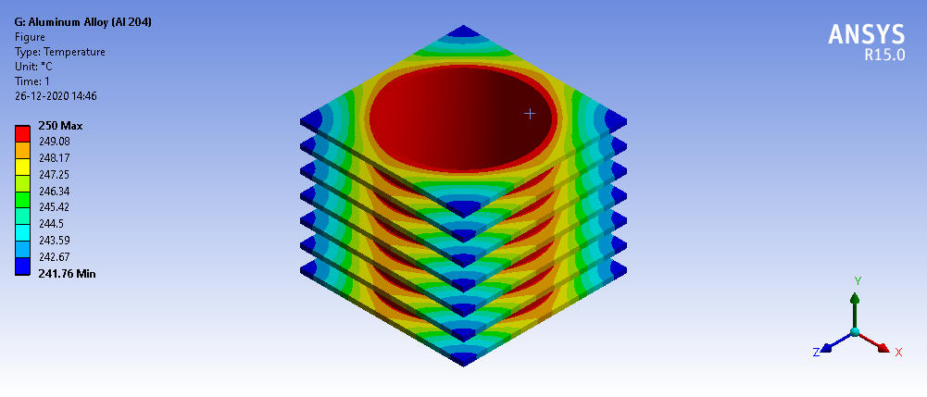

**Figure 7: Temperature distribution of Al204 fin**

In table 4 we describe Al204 alloy fins which have the maximum and minimum temperature as well as total flux which is shown in the table.

**Table 4****: Temperature and total heat flux in Al204Alloy**

|  |  |  |
| --- | --- | --- |
| **Value** | **Temperature (0C)** | **Total heat flux (W/m2)** |
| Max. | 250 | 1.1993e+005 |
| Min. | 241.76 | 2463.3 |

## 3.2 AL6061 ALLOY

Al6061 has the following properties for which the analysis has been done. The Total heat flux and temperature distribution have been calculated for Al6061 alloy.

**Table 5:** **Material Properties: [11]**

|  |  |
| --- | --- |
| **Property** | **Value** |
| Density(Kg/m3) | 2700 |
| Specific heat (J/Kg/0c) | 1256 |
| Thermal Conductivity (Watt/m/0c) | 167 |

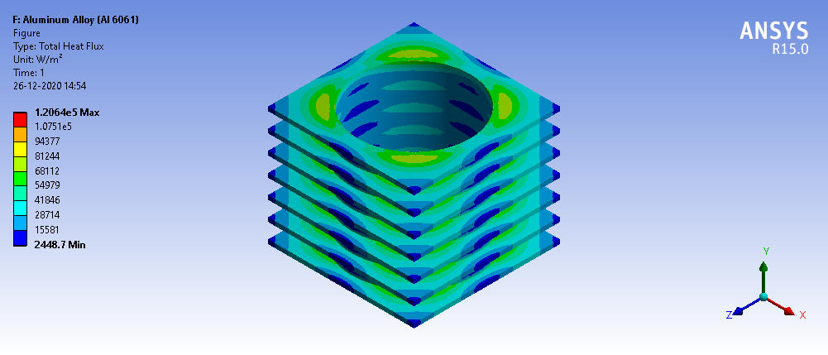

**Figure 8: Total heat flux of Al6061 alloy**

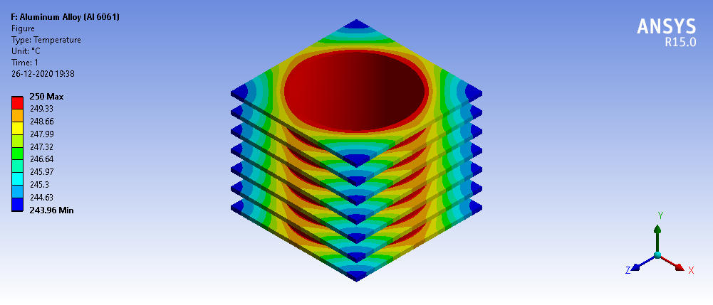

**Figure 9:** **Temperature of Al6061 alloy**

In table 6 it is described Al6061 alloy fins which have the maximum and minimum temperature as well as total flux which is shown in the table.

**Table 6****: Temperature and total heat flux in Al6061 alloy**

|  |  |  |
| --- | --- | --- |
| **Value** | **Temperature (0C)** | **Total heat flux (W/m2)** |
| Max. | 250 | 1.2064e+005 |
| Min. | 243.96 | 2448.7 |

## 3.3 AL6063ALLOY

The Material Properties of Al6063 fin are shown in table 7 and with the help of these properties the analysis has been done and Total heat flux and Temperature distribution are calculated.

**Table 7****: Material Properties. [10]**

|  |  |
| --- | --- |
| **Property** | **Value** |
| Density (Kg/m3) | 2770 |
| Specific heat (J/Kg/0c) | 875 |
| Thermal Conductivity (Watt/m/0c) | 170 |

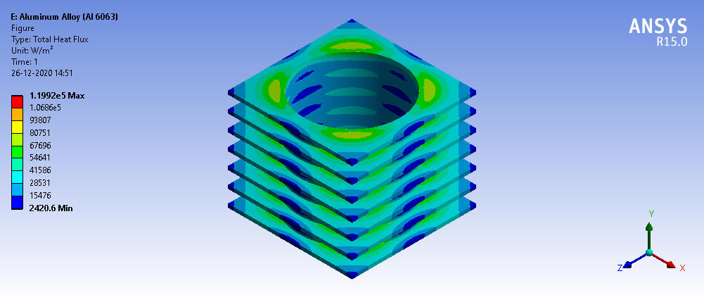

**Figure 10: Total heat flux in Al6063 alloy fin**

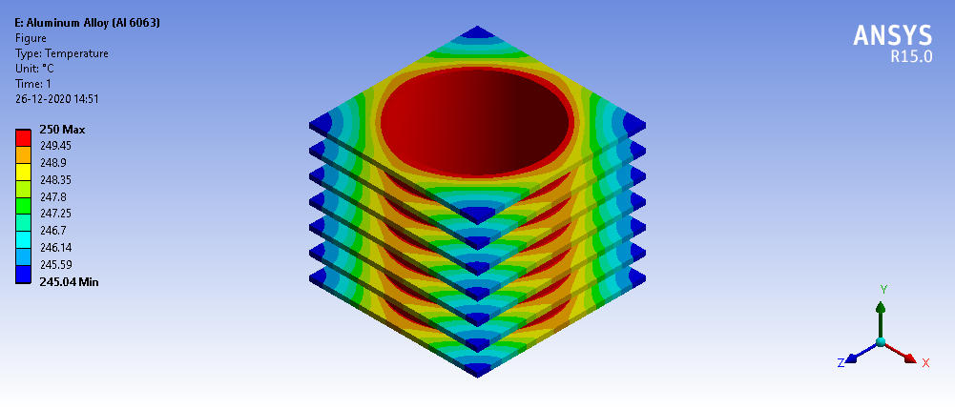

**Figure 11: Temperature distribution in Al6063 alloy**

In table 8 it is described Al6063 alloy which has the maximum and minimum temperature as well as total flux which is shown in the table.

**Table 8****: Temperature and total heat flux in Al6063 Alloy:**

|  |  |  |
| --- | --- | --- |
| **Value** | **Temperature (0C)** | **Total heat flux (W/m2)** |
| Max. | 250 | 1.1992e+005 |
| Min. | 245.04 | 2420.6 |

**Table 9: Comparison of all types of fin:**

|  |  |  |  |
| --- | --- | --- | --- |
| **Type of Fin** | **Input Temp(0C)** | **Output Temp (0C)** | **Heat Flux (W/m2) Max.** |
| Al204 Alloy | 250 | 241.76 | 1.1993e+005 |
| A6061 Alloy | 250 | 243.96 | 1.2064e+005 |
| Al6063 Alloy | 250 | 245.04 | 1.1992e+005 |

## 3.4 GRAPHICAL REPRESENTATION OF TEMPERATURE DROP AND MAX. HEAT FLUX

**Figure 12: Temperature drop for Al Alloy Fin**

**Figure13: Maximum heat flux for Al Alloy Fins**

In the result section of comparison and from the above graphical representation for Al alloy fins the value of Temperature range and the value of maximum total heat flux is obtained. From the above two graphs, it is noticeable that the temperature drop is highest for Al204 followed by Al6061 alloy and Al6063 being least. Heat flux is max. For Al6061 alloy followed by Al204 alloy and Al6063 alloy.

# CONCLUSION

In this paper, a rectangular fin of Hero Super Splendor motorcycle is modeled in parametric 3D modeling software Solid works. Steady-state thermal analysis was performed using Ansys Software. The material used currently for the fin is Al204. Materials used for comparison were Al6061 and Al6061 having almost the same density i.e. weight. From the analysis, by observing the results it is seen that the Temperature distribution range is best for Al204 followed by Al 6061. Heat flux is best for Al6061 followed by Al204.

From the graph of Temperature drop and heat flux, it is noticeable that variation in Max. Heat flux is more significant and varies to a higher numerical value as compared to the temperature drop, which is highest for Al6061. Further Al6061 alloy has a density value (2700) slightly lesser than Al204 (2800).

Thus, by comparing all the results it is concluded that the best material for a two-wheeler should have high heat transfer, high strength, and light in weight. Hence Al6061 is the best-suited material for the light vehicle due to its light weight, good temperature range, and better heat Flux as compared to other materials.

# REFERENCES

1. *Pritam Pain, Deep Dewan,” Design and specification of internal combustion engine”, International Research Journal of Engineering and Technology (IRJET), Volume: 06 Issue: 09, Sep 2019.*
2. *Rahul T L “Recent Trends in Internal Combustion Engine”, International Research Journal of Engineering and Technology (IRJET), Volume 07 Issue: 04, Apr 2020.*
3. *J-J Zheng, J-H Wang, B Wang, and Z-H Huang “Effect of the compression ratio on the performance and combustion of a natural-gas direct-injection engine” September 2008, DOI: 10.1243/09544070J AUTO976.*
4. *Jovan Dorić, Ivan J. KLINAR “Efficiency of a new internal combustion engine concept with variable piston motion”, Thermal Science- January 2014, DOI: 10.2298/TSCI110923020D.*
5. *Ismail Durgun, Hasan Ayarturk, Arda Odabaşıoglu “Engine cooling system without radiator” Simea-August 2015, DOI: 10.5151/engpro-simea2015-PAP142.*
6. *T U H S G Manik1, A Zikri, R Irfandi and T B Sitorus, “Performance analyses of engine radiator system with capacity 1000 cc” IOP Conf. Series: Materials Science and Engineering 505 (2019) 012003, doi:10.1088/1757-899X/505/1/012003*
7. *Tao He, Chunlei Mei, Jon P. Longtin,“Thermosyphon-assisted cooling system for refrigeration applications”, international journal of refrigeration 74 ( 2 0 1 7 ) 165-176*
8. *Babu, G. (2013). Heat Transfer Analysis and Optimization of Engine Cylinder Fins of Varying Geometry and Material. IOSR Journal of Mechanical and Civil Engineering, 7(4), 24–29.*
9. *Sagar, P., Teotia, P., Sahlot, A. D., & Thakur, H. C. (2017). Heat transfer analysis and optimization of engine fins of varying surface roughness. Materials Today: Proceedings, 4(8), 8565–8570. https://doi.org/10.1016/j.matpr.2017.07.203*
10. *Reddy Kummitha, O., & Reddy, B. V. R. (2017). Thermal Analysis of cylinder block with fins for different materials using ANSYS. Materials Today: Proceedings, 4(8), 8142–8148.*
11. *M Syamala Devi, E Venkateswara Rao, K Sunil Ratna Kumar," Optimization of Engine Cylinder Fin by Varying its Geometry and Material," International Journal of Science and Research (IJSR), ISSN (Online): 2319-7064, Index Copernicus Value (2013): 6.14, Impact Factor (2014): 5.611.*
12. *Belinskiy, B. P., Hiestand, J. W., & Weerasena, L. (2020). Optimal design of a fin in steady-state. Applied Mathematical Modelling, 77, 1188–1200. https://doi.org/10.1016/j.apm.2019.09.038*