**“Recreating Mergers and Acquisitions (M&As) Competencies in**

**the Post–Covid-19 World - Moving towards the new normal”**

Vartika Awasthi

Research Scholar

Dr. Rammanohar Lohia Avadh University,

Ayodhya, Uttar Pradesh

e-mail- [vartikaa05@gmail.com](mailto:vartikaa05@gmail.com)

Ph.no. - 8765091835

Dr. Neelam Maurya

Assistant Professor

Government P.G. College,

Musaffirkhana, Uttar Pradesh

e-mail- [Neelammaurya786@gmail.com](mailto:Neelammaurya786@gmail.com)

Ph. no. - 9838665103

**“Recreating Mergers and Acquisitions (M&As) Competencies in**

**the Post–Covid-19 World - Moving towards the new normal”**

**Abstract**

*The outbreak of Covid-19 pandemic brought a number of unprecedented challenges for the Indian economy. While India experienced a tough resurgence in the first wave of Covid-19, the second wave impacted the country more devastatingly. A huge rise in the number of Covid-19 cases further slowed down the recovery of Indian economy. Companies all over the world have faced a lot of significant disturbances and uncertainties in managing operations of their businesses such as unforeseeable losses, disturbed supply chains, blocked working capital, liquidity crisis and risk of business continuity. The pandemic also had a noteworthy impact on Mergers and Acquisition (M&As) activities all over the world. Due to this reason, many companies have either put their acquisition and growth plans on hold or postponed it, moving their focus towards cash management and internal group simplification against such business challenges.*

*This research paper primarily focuses on exploring the impact of Covid-19 pandemic on global mergers and acquisition (M&As) activity through analyzing statistical data related to volume, value, and type of transactions taken place. The objective of this study is to get an idea regarding how mergers, acquisitions and other restructuring activities have been utilized amidst these challenging times. This research paper illustrates the deliberate change taking place in the deal world in order to present a possible outlook of the M&As deal market in the post-pandemic era. In such difficult situation, companies need to evaluate the possible impact of Covid-19 on their businesses and plan accordingly the future course of action. It is essential to reorganize strategy for reformation of opportunities to support their businesses, acquisitions and structures which is necessary for their survival.*

*Therefore, it is very crucial to take remedial measures by adopting some new strategies for the creation of a significant path which leads towards the new normal.*

***Keywords-*** *Mergers and Acquisition (M&As), Covid-19, post-pandemic, restructuring activities, M&As deal market.*

**Introduction**

The occurrence of Covid-19 pandemic effected most of the corporate operations very severely due to lack of primacy and preparedness of these companies to face such an exogenous situation. Moreover, the whole world’s population had been locked inside their homes for health and safety reasons. Many were expectant about an economic recession in 2020 but nobody predicted the occurrence of such wide economic fluctuations due to this pandemic. Moreover, the restrictions imposed by the government and supply and demand constraints have made the firm’s incapable of facing the new business environment formed as a result of this health crisis.The pandemic also had a noteworthy impact on Mergers and Acquisition (M&As) activities all over the world. Due to this reason, many companies have either put their acquisition and growth plans on hold or postponed it, moving their focus towards cash management and internal group simplification against such business challenges.

After one year to this pandemic, we could observe that some companies had the privilege of earning profits even in these economic downturns, while other companies had to suffer hard for their survival and even cease their operations for some time. Globally the M&As deal market slowed down but it never reached to a zero volume. There were some companies which made use of the disaster of Covid-19 as an opportunity to further expand their portfolios through mergers and acquisitions resulting in a strong balance sheet for them. While some other companies were enforced to divest a portion of their business to get rid of the surplus burden. They had to deal with major hurdles in estimating cash flows and their accurate valuation keeping in mind the unpredictability of this pandemic. For those companies which were looking for reorganizing their strategic plans to better compete, mergers, acquisitions, and corporate restructurings have resulted in key considerations for their survival. This pandemic was a surprise for the whole world which tested the flexibility of companies in this new environment showing how the countries globally will recover and adapt to different consumer and organizational behaviors.

Mergers and Acquisitions (M&As) have gone through a significant change during this Covid-19 crisis. In the present scenario, owing to positive government intervention and a secured banking system, M&As forecasts have shown a favorable atmosphere for their growth. The want of domestic consolidation in the Covid-19 affected segments has resulted in creation of new investment opportunities for various industries across border or across sector. Now, India is growing as a new and attractive manufacturing and investment hub for the whole world. This pandemic has caused a serious chaos all around the globe and enforced countries to adopt for solution-centric methods. The threat of this unfamiliar situation has changed the way of formulating and implementing corporate growth strategies. Nowadays, indemnity insurance and policy coverage have become a major need than before. M&A strategies, post covid-19, will now intrinsically adapt to environmental, social and governance (ESG) principles in order to fulfill their CSR mandate.

Government of India has introduced many directives in order to create new opportunities for M&As. The commencement of telemedicine and door-step delivery have provided for new opportunities in the health sector of India. Moreover, the development of such a large number of vaccines in record time resulted in a speedy advancement in the healthcare sector. This intellect of developing vaccines in merely few months was determined by the necessity and purposefulness of several enterprising collaborations.

As companies are moving on the way to their revival, M&As activities will have an enormous influence in determining the ‘new normal’. But, at the same time, it is expected that deal market will change significantly to replicate the new opportunities. Unlike traditional M&As, now companies have to organize a broad array of expansion strategies such as joint venture with their peers, co-investments with private equity, investment in varied technologies, cross-sector alliances with specialists and governments. Redefining M&As in these circumstances and choices will bring much desired precision of rationale in dealing with uncertainties.

**Literature Review**

[**Bauer**](https://www.emerald.com/insight/search?q=Florian%20Bauer)**,**[**Friesl**](https://www.emerald.com/insight/search?q=Martin%20Friesl) **and**[**Dao**](https://www.emerald.com/insight/search?q=Mai%20Anh%20Dao)**(2022)** conducted a study on how M&As behavior got affected by the financial breakdown brought up by the Covid-19 pandemic. They used mixed method research design in their study. The author’s investigation revealed that goal selection as well as synergy management was severely affected by this pandemic. Moreover, M&As involve high risk level resulting in mixed performance even under normal conditions.

**Kooli, C., & Lock Son, M. (2021)** in their study discussed about the most probable viewpoint of the M&As deal market in this post-pandemic situation and demonstrated how a sudden change has taken place in the deal world. The study concluded that M&As will facilitate companies to look out future prospects in structurally diverse business models and adapt to the new technology.

**Dr. S. Pramila (2021)** examined the viewpoint of employees and the mind-set of clients with respect to mergers and acquisitions in the Covid-19 breakout. This paper analyzed 10 retail banks and saving banks in the Indian banking industry between 2019 and 2020 in terms of M&As. The study suggested that financial M&As had a negative impact on prices, position and nearness of branches and had a positive impact on products and services post pandemic.

**Winkler & Malta (2020)** conducted an original case study on the failed sale of Victoria’s Secret’s business to scrutinize the impact of the Covid-19 pandemic in terms of M&As dealings. The author in this case study has tried to put forward a multifaceted scrutiny of the consequences of Covid-19 with respect to the type of event, and has explored the possible reasons of the dramatic variations in the target’s value as a result of Covid-19.

**Fu, M. & Shen (2020)** studied the performance of energy companies during the outburst of Covid-19. The study found that the Covid-19 pandemic had a negative impact on the commercial performance of the energy sector which started falling in the first quarter of 2020. The performance of companies was negatively exaggerated by Covid-19 resulting in business risks driven by goodwill.

**Objectives of the Study**

* To explore the impact of Covid-19 pandemic on Mergers and Acquisition (M&As) activities in India.
* To get an idea regarding how mergers, acquisitions and other restructuring activities have been utilized amidst these challenging times.
* To illustrate the measures taken to limit the impact of Covid-19 pandemic on M&As transactions.
* To present a possible outlook of the M&As deal market in the post-pandemic era.

**Hypotheses of the Study**

H0: There is no significant impact of Covid-19 pandemic on Mergers and Acquisition (M&As) activities in India.

H1: There is a significant impact of Covid-19 pandemic on Mergers and Acquisition (M&As) activities in India.

**Research Methodology**

The present paper explores the impact of Covid-19 on mergers, acquisitions, and corporate restructuring activities through undertaking a detailed literature review of previous research studies. In addition to this, an analysis of the statistical data collected by global institutions presents a better view of both the short and long-term effects of this unexpected incident on global M&As. The present study also examines how mergers, acquisitions, and other corporate restructuring activities have been employed to harmonize the changes taken place as a result of this pandemic and resulted in value creation. This paper also discusses the trends showing the changes in M&As activities which will be visible in the post-pandemic world.

**M&As Activity amidst Covid-19**

The extent of Covid-19 crisis was unexpected by the government and companies all over the world. Notably, both the value and volume of deal got slightly reduced after Covid-19. During the first half of 2020 the deal volume fell down to 49%, whereas the deal value dropped to 22%. As a result, a number of deals have been fallen all over the world. This huge fall brought some other monetary shocks as well which resulted in an immerse fall of up to 50% in the deal value. Although, this fall was previously mostly prominent with mega-deals, while smaller deals were persistent as companies look for M&As as a solution to their solvency and thus, discarded their assets and distressed businesses. Some of the challenges were unique to each company which included numerous common questions and decisions regarding M&As. Any action taken by the companies will affect both their current and future feasibility. Companies and industries have to undertake strategic moves which will bring stability and create new futures for them.

**Figure 1: Factors impacted M&As activities in 2020.**

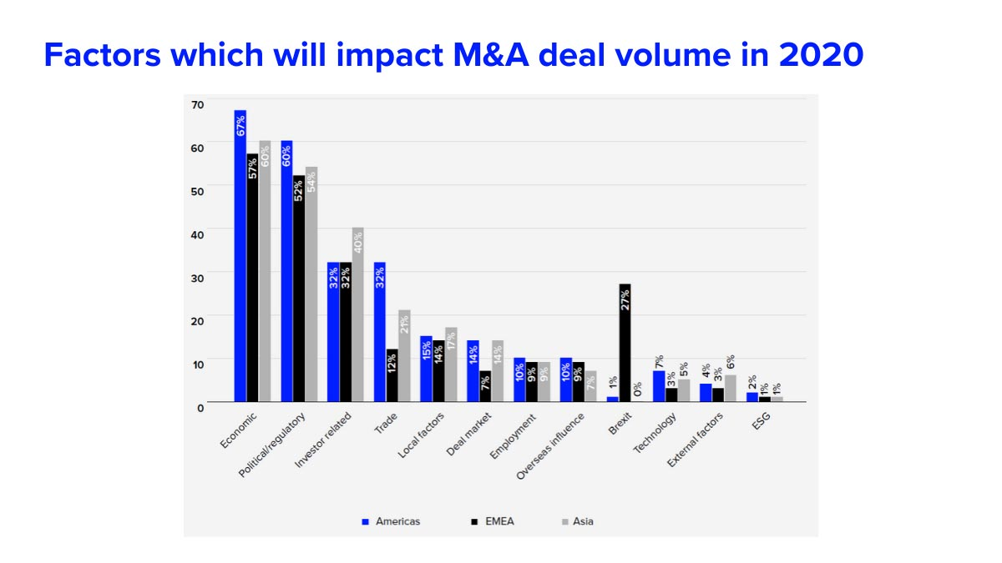

Source – Data collected from Refinitiv.

Global mergers and acquisition activity crossed the pre-pandemic level in 2021 with no trouble and was even more than the peak of 2015. It is expected that M&As will reach to higher levels in the coming years. Through effortless reach to capital, lower rates of interest and an improving global economy, deal makers in the whole world proclaimed a net value of almost 5.8 trillion dollars of M&As dealings in 2021 which is very up from last year’s net value of 3.8 trillion dollars. Companies all over the world stated that their eagerness for M&As in 2022 would be influenced by a number of factors. It includes high rate of valuation, level of inflation in the economy and number of profitable targets available. One more important factor for some financiers is the probability of an increase in the cost of capital along with increase in taxes.

**Figure 2: Global Volumes and Values of M&As Deal Activities.**

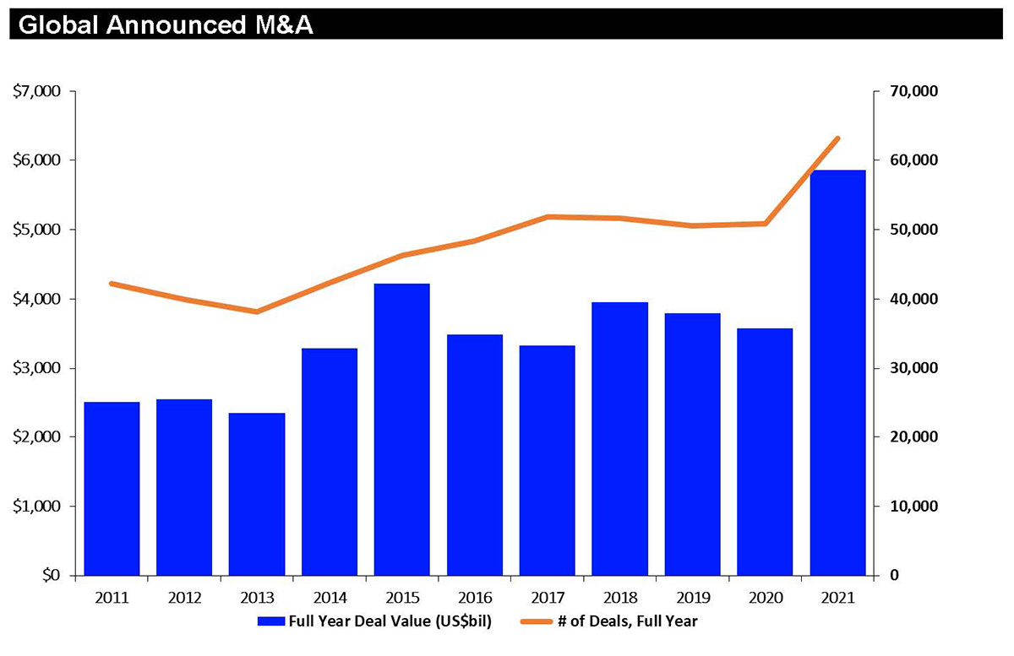

Source – Data collected from Refinitiv.

[**Measures taken to limit the impact of Covid-19 on M&As transactions**](https://www.ey.com/en_us/webcasts/2020/07/impact-of-covid-19-on-executing-m-and-a-transactions).

The outburst of Covid-19 pandemic resulted in vivid business disturbances and financial chaos. Many steps have been undertaken to limit its spread all over the world. Some latest considerations have been issued for parties contributing in projected or awaiting M&As dealings to review their exposure to unsolicited offers. There are apparently endless problems which companies have to counter in particular interest to M&As participants. Following is a summary of potential measures taken to limit the impact of Covid-19 pandemic on M&As transactions.

* **Due Diligence-** The procedure of due diligence involves very close coordination between teams as well as cautious allotment of tasks and duties to make sure that each area of inspection is considered. It helps in evaluating the impact of current events on regulatory developments and industry trends of the business. Keeping in mind the operational risks, buyers should think about the impact of Covid-19 pandemic on the operations.
* **Internal Reorganization-** There are various companies which deal in similar or related businesses who face the constraint of utilization of available resources within several businesses resulting in duplicity of cost. . Due to these reasons, it has become a necessity in the current state to re-evaluate the need of these structures and make use of available resources in more efficient manner.
* **M&As Agreements-** Various parties negotiating M&Asagreements should consider the likely impact of this uncertain Covid-19 pandemic on the assumptions essential to an agreement keeping in mind the unpredictability of future dealings. It includes assumptions concerning future performance and various risks created by this pandemic which need to be considered under this agreement.
* **Financing-**The risks of financing attached with the agreement should be evaluated carefully while preparing the outline of documents needed for financing the agreement.
* **Duration of M&As Process-** Covid-19 pandemic caused a noteworthy impact on the timing of M&As transactions. Now physical meetings cannot be used for undertaking discussions, government processes and other routine matters. Various agencies have provided for certain relief measures in meeting formalities under these circumstances. Also, parties should think about this hindrance caused by the delay in negotiations.
* **Working capital management-** Companies which have sufficient cash reserves but are not capable of distributing it should adapt to capital reduction so that they could distribute the surplus cash. Moreover, companies should try to save cash in present time for enhancing their working capital so that they can attain a better liquidity position.
* **Optimal capital structure-** Companies which resort to external borrowing are highly leveraged. They should try to reduce the level of debt in their company and attain optimal capital structure so that profitability of the company could be raised. Profitable companies having sufficient cash reserves could possibly choose to reward its shareholders through dividend or buy-back of shares.
* **Consolidation of businesses**- The most widely used method of consolidation of businesses is merger of companies. Mergers are usually considered as the most efficient way of increasing value of a company by pooling cash resources and eliminating administrative costs. Thus, it is suitable to consolidate the businesses or entities for attaining synergy in operations and reducing administrative compliances.
* **Convertibility of debt into equity-** This measure would be appropriate for those companies which are receiving income from interest and the borrowing company is not competent enough to pay the interest due to losses, in view of the recent slowdown.

Therefore, it is advised to convert the existing debt from various companies into equity or other convertible instruments.

**M&As Trends in 2022**

The pattern of M&As in 2022 will be influenced by a number of factors comprising of both microeconomic and macroeconomic variables. Some of the widest impact on M&As deal activities are high valuations, liquidity crisis, intense competition for well esteemed targets and factors affecting supply chain. The existing condition of pandemic has brought businesses and companies into an idle state. Those businesses which got impacted with this are seeking for their survival instead of thinking of growth plans for future. Many firms have attained financial support during such financial crisis to get into a better position and compete in the market. On the other hand, some companies are stable enough to adapt for expansion into numerous other businesses and make use of this opportunity by exploring further possibilities of investments. The Covid-19 crisis has distinctively impacted both human and economic activities. This resulted in a contraction in M&As deal market. Companies that framed strategies for M&As usually surpassed those who do not. While evaluating opportunities for growth after this slump, optimistic leaders now need to act in response of bringing stability of risk and liquidity.

Easy accessibility of surplus capital and financial optimism stimulated domestic M&As in 2021. CEOs in India are also considerably optimistic regarding the projection of a recovered economy in the next year. Companies liquidated their unprofitable assets to rationalize huge corporate structures, making them more efficient and consecutively invested the cash into new assets. Moreover, in this post-pandemic world, companies need to respond more rapidly to their competitors so that they could acquire a better position, particularly in the retail and consumer goods segments. Due to these reasons, companies will carry on their search for acquisitions in the overseas deal markets in order to enter into new markets, enlarge their current portfolios and attain harmonizing business competencies.

Thus, it is estimated that in the year 2022 also, this tendency of outbound acquisitions and the momentum of deal activity will be carried on at a higher level.

**Discussions and Suggestions**

M&As deals in 2021 have been on a predominantly remarkable point and are on the way to further raise their share in deal making in 2022. There were certain elements which resulted in creating a record in M&As deal market. Since the companies got a better understanding of the financial markets in view of the Covid-19 pandemic, it resulted in creation of opportunities for both the buyers and sellers leading to a return to the preliminary phase of diligence. Companies will now put their focus on reinvestment to bring equilibrium and long term growth in their portfolios. This is because now companies insist on creating a better value approach globally. Moreover, M&As decision making will be influenced by a deliberate change to digital and innovative business models.

With more startup companies entering in the market, it is expected that more unicorn companies will be seen, making the year 2022 much better. Several commitments have been made by companies to reduce carbon emissions by making use of greener sources of energy and thus, creating opportunities for M&As market. Moreover, the real estate and logistics sectors are expecting huge recovery and return back to normal due to e-commerce and supply chain optimization resulting in an increase in demand of real estate. These sectors are expected to remain strong in the year 2022 as the steady growth from the year of 2021 will continue to last in the next year also.

The uncertainty regarding future forecasts and risks impose various challenges for the dealmakers. In order to find the best method to counter the challenges faced by the parties in the present M&As deal market, it is necessary to undertake a vigilant scrutiny of the facts and conditions related to the projected business deal. Moreover, companies opting for M&As should put down a comprehensive and lucid plan keeping in mind their acquisition goals so as to make their M&As planning and due diligence successful. By taking these precautions both the buyers and sellers will be able to find satisfactory answers to their various problems and also get the opportunity to further grow in the M&As deal market.

**Conclusion**

Covid-19 pandemic uncovered the various shortcomings of nearly each business entity. Every disaster produces certain opportunities for the businesses to make best use of their abilities and push themselves to come out of the downturn. Considering the Covid-19 pandemic, M&As alliances prove to be an effective way of creating a sense of balance. M&As can be used to develop a more flexible network of partners and to further expand the operations of a firm. These networks play a vital role in solving the problems of many business entities also helped them in coming out of this crisis. The lessons taught by this pandemic made the companies adapt to M&As for their growth and resilience.

Majority of companies will opt for disinvestments and dispose-off NPAs for improving their liquidity position and making their balance sheets favorable. There will be plenty of opportunities in the year 2022 for companies to enter into new markets and expand themselves. Corporate mergers and acquisitions (M&As) have gone through a significant variation during the Covid-19 pandemic. In this unexpected situation, initially M&As activity suffered a fall both in terms of deal value and volume.

In the context of the present study, the null hypothesis does not hold true and it is rejected. Thus, it is concluded that there is a significant impact of Covid-19 pandemic on Mergers and Acquisition (M&As) activities in India. In the beginning of the year 2020, M&As activities have shown a declining trend in various sectors but as soon as recovery took place things became better. In the present optimistic atmosphere, M&As deal markets have grown further with the help of a stable banking system and a supportive government. Now, it has become the need of the hour for the companies to restructure their businesses according to the growth prospects and make use of an optimum combination of debt and equity in their businesses.

Therefore, companies should recognize every possible opportunity and consequently reorganize their activities so that they could accomplish their desired goals and objectives feasibly in the longer time period.

**References**

1. [Bauer, F.](https://www.emerald.com/insight/search?q=Florian%20Bauer), [Friesl, M.](https://www.emerald.com/insight/search?q=Martin%20Friesl) and [Dao, M.A.](https://www.emerald.com/insight/search?q=Mai%20Anh%20Dao) (2022), "Run or hide: changes in acquisition behaviour during the COVID-19 pandemic", [*Journal of Strategy and Management*](https://www.emerald.com/insight/publication/issn/1755-425X), Vol. 15 No. 1, pp. 38-53. <https://doi.org/10.1108/JSMA-02-2021-0046>
2. Conahan, J. B. (2020, April 22). *COVID-19: M&A Considerations During the COVID-19 Pandemic*. Retrieved from Wilmerhale: https://www.wilmerhale.com
3. Dr. S. Pramila, D. V. (2021). The Effect of Merger, Acquisition and Covid-19 on Customers Service of Union Bank of India Delhi. *PSYCHOLOGY AND EDUCATION* *, 58* (2), pp. 9880-9887.
4. Fu, M., & Shen, H. (2020). COVID-19 and Corporate Performance in the Energy Industry. Energy RESEARCH LETTERS, 1(1). <https://doi.org/10.46557/001c.12967>
5. Kooli, C., & Lock Son, M. (2021). “Impact of COVID-19 on Mergers, Acquisitions & Corporate Restructurings Businesses”, *1*(2), pp. 102–114. <https://doi.org/10.3390/businesses1020008>
6. <https://home.kpmg/dp/en/home/insights/2021/12/blowout-year-global-ma.html>
7. <https://media2.mofo.com/images/220121-ma-trends-2022-chart1.jpg>
8. [https://2flg6t6vy7aov8osu0n9v16l-wpengine.netdna-ssl.com/wp content/uploads/2020/03/3-COVID-19-bursts-MA-activity-optimism-03-2020.jpg](https://2flg6t6vy7aov8osu0n9v16l-wpengine.netdna-ssl.com/wp%20content/uploads/2020/03/3-COVID-19-bursts-MA-activity-optimism-03-2020.jpg)
9. Winkler, M and Malta, N. (2020, November 8). COVID-19 as a Deal-Killer in Mergers and Acquisitions: A Case Study. The Law of International Trade, pp. 857-870, Available at SSRN: <https://ssrn.com/abstract=3729430>